DATA 555 Project 1

Marketing Sales Regression Report
I selected the Marketing Outcome Prediction from Project Descriptions. The data had 4,572 rows and five columns. I used TV, Radio, and Social Media to predict Sales, and I did not use Influencer because it is text. I checked the data types, missing values, and duplicate rows. I removed 26 incomplete rows, so 4,546 rows remained.
I used a scatter plot because TV and Sales are numeric variables. The plot showed a strong positive relationship between TV and Sales:
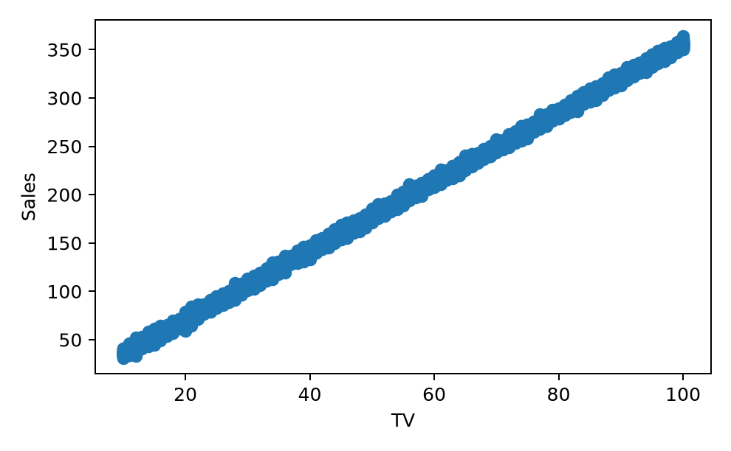
I also compared Radio and Social Media with Sales. Both plots showed a positive relationship, but the points were more spread out than in the TV plot. Their relationships with Sales were therefore weaker than the TV relationship.
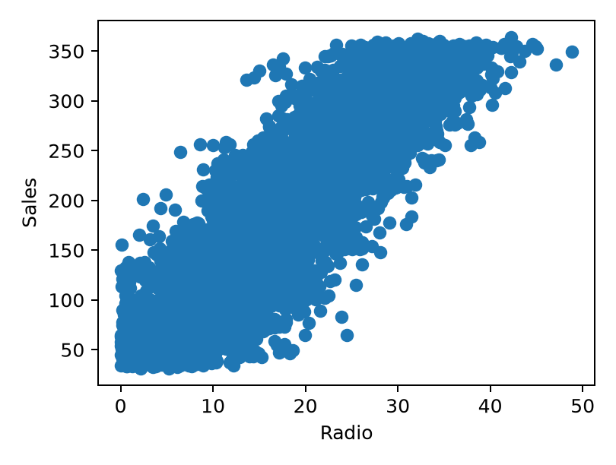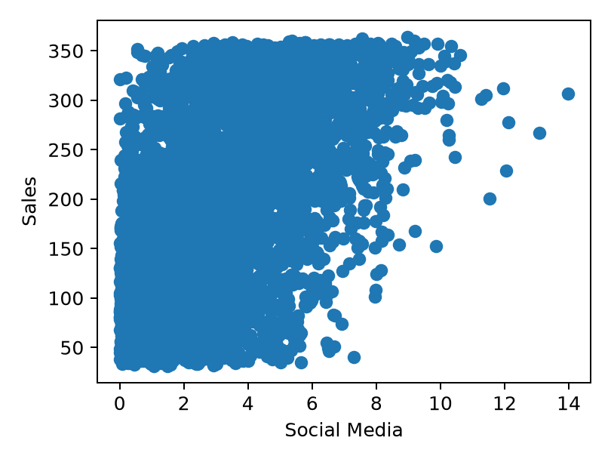
I used 80% of the data to train a multiple linear regression model and 20% to test it. The model had an R-squared of 0.999 and an RMSE of 2.88, so the predictions were close to actual Sales. TV was the main predictor in this model.
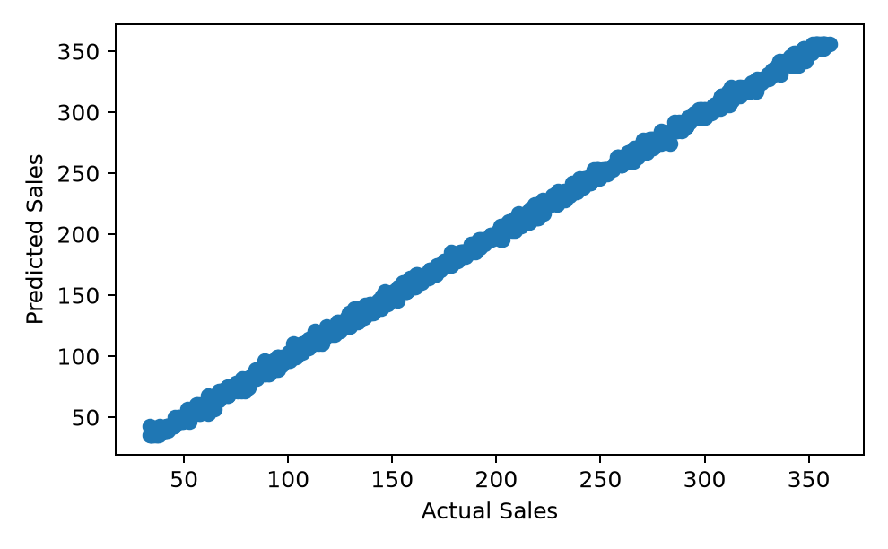
The second plot compares actual Sales with predicted Sales. Most points followed a narrow diagonal line, which shows that the predicted values were usually close to the actual values.
TV had the clearest relationship with Sales in this model. Radio and Social Media changed the predictions very little after TV was included.
I also checked the prediction errors. Most errors stayed close to zero and did not show a clear curve.
